SUPPORTING INFORMATION

**Numerically dominant species drive patterns in resource use along a vertical gradient in tropical ant assemblages**

Stephanie J. Law*, and Catherine Parr1,2,3

*Department of Earth, Ocean and Ecological Sciences, School of Environmental Sciences, University of Liverpool, UK.1*

*Department of Zoology & Entomology, University of Pretoria, Pretoria 0002, South Africa.2*

*School of Animal, Plant and Environmental Sciences, University of the Witwatersrand, Wits 2050, South Africa.3*

*\*Corresponding author, email:* [*stephaniejanelaw@gmail.c*](mailto:stephaniejanelaw@gmail.c)*om*

Appendix S1. Study site and sampling method

The study area was located in lowland, old growth dipterocarp rainforest in Maliau Basin Conservation Area, Sabah, Malaysia (4° 44' 35" to 55" N and 116° 58' 10" to 30" E; over 2013-2018 mean monthly temperature 24.9oC 3.1oC, mean monthly rainfall 165 mm $±$ 70 mm; mean monthly humidity 77% $±$ 16%, Belian Meteorological Station, Maliau Basin Conservation Area). All sampling took place within four experimental plots each measuring 50 m x 50 m and spaced at least 100 m apart. Altogether 12 trees were selected for our study: three trees within each plot that were either emergent or reached the high canopy. It was not possible to select trees of the same species due to the limited number of trees safe to climb within each 50 m x 50 m plot, however all trees were Dipterocarpaceae belonging to the genera *Parashorea* or *Shorea*. All trees were measured with a tape measure to the highest climbable point and the total height then estimated to the nearest meter. The surveyed trees ranged in total height from 27 to 52 m (mean $±$ SD = 38 m $±$ 8) with the diameter at breast height (dbh) ranging from 41 to 105 cm (mean $±$ SD = 66 cm $±$ 20).

Ants were collected from February to May 2016 using baited traps similar to the baited pitfall trap method described by Yusah, Fayle, Harris, & Foster, (2012). On each tree, sampling stations were set vertically every 5 m from the ground to as high up into the canopy as possible. The number of traps set on each tree ranged from 28 to 44 (mean $±$ SD = 35 $±$ 6). The strata (canopy or trunk) of each trap location was also recorded, traps placed above the first branch were identified as the canopy and traps below the first branch as understory. Each sampling station comprised two pairs of baited traps (four traps in total). A pair of traps comprised two plastic cups 8 cm in diameter tied together with a piece of string. A carbohydrate bait (oat and honey mixture) was placed in one cup and protein (tuna) in the second cup. Baits were suspended in mesh bags hung from the center of a wire across the top of each cup. Water containing a small amount of detergent was placed in the bottom of cups to break the surface tension. Pairs of traps were hung over nails on opposite sides of the trunk at each height interval (Fig S1.1). Traps within each pair were separated by 20 cm and left open for 24 hours.

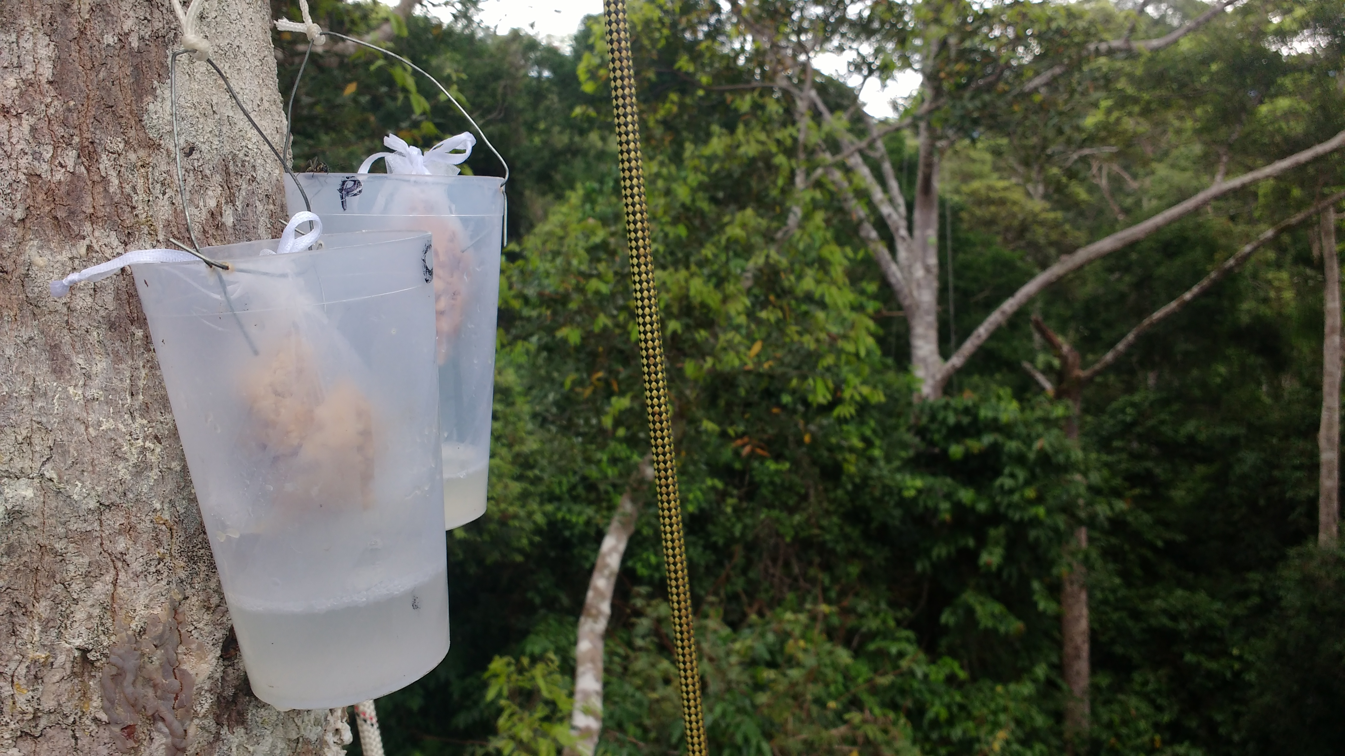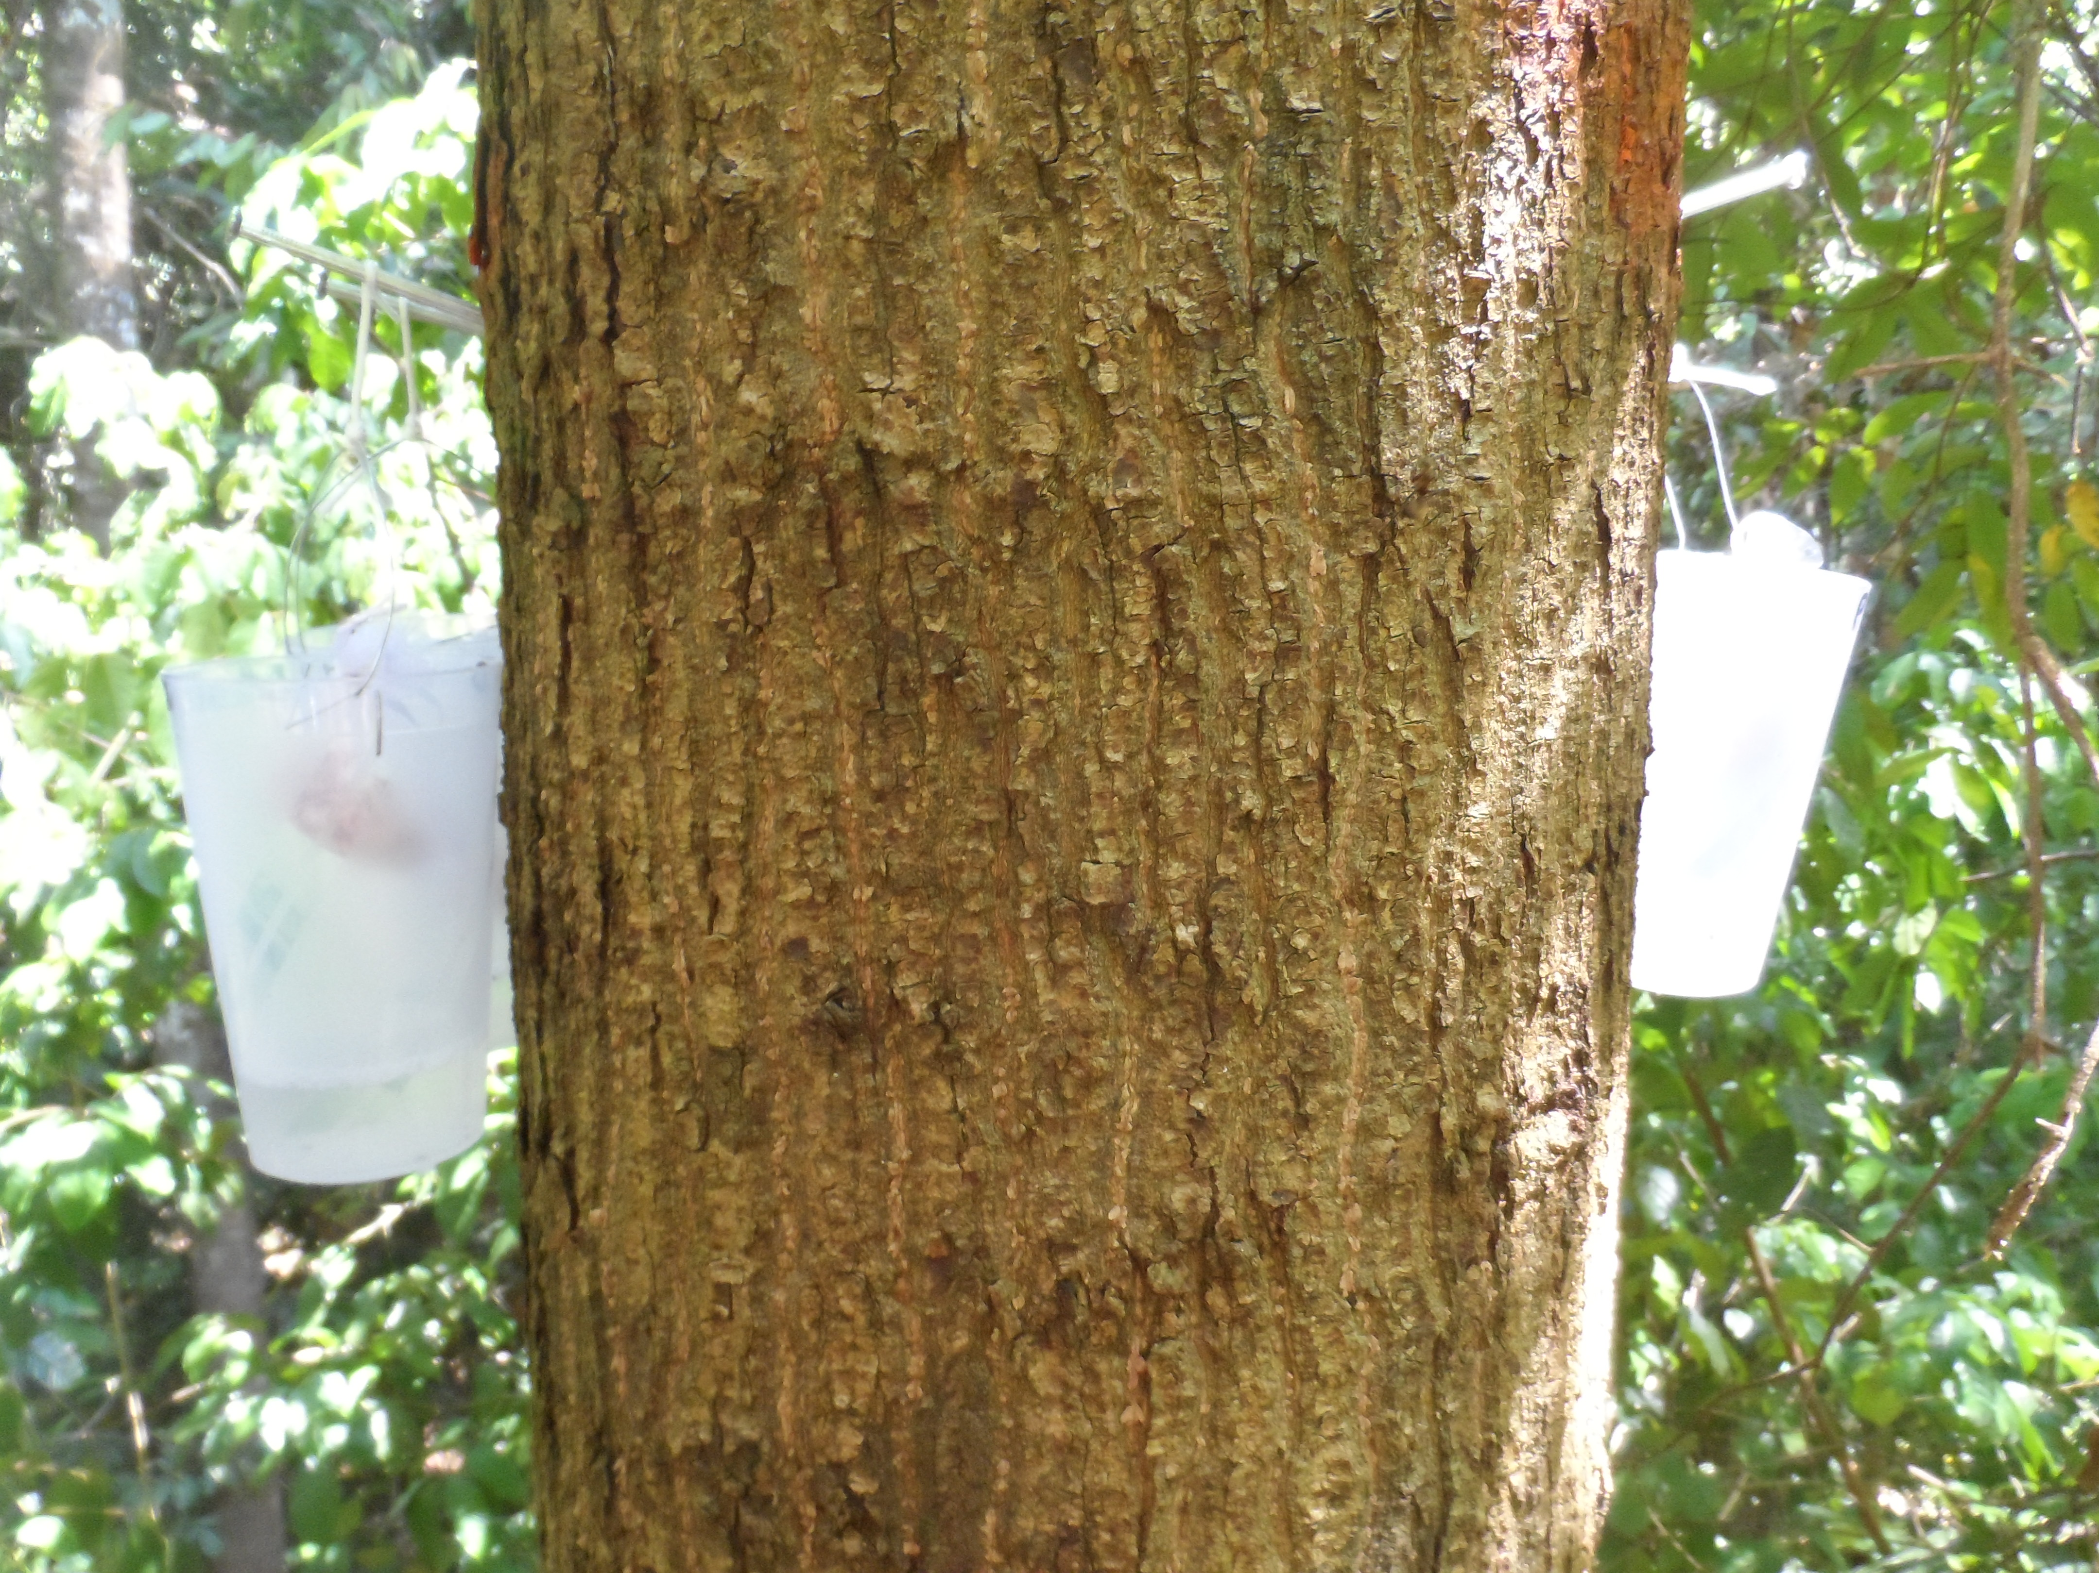

Figure S1.1. Images show baited traps at a sampling station.

Appendix S2. Species composition

The top ranking species in terms of occurrence belong to the larger bodied genera *Camponotus* and *Polyrhachis* while the top ranking species in terms of abundance belong to the smaller bodied genera *Monomorium, Vollenhovia* and *Crematogaster*. These differences in top ranking species reflect differences in body size. It may be that larger bodied species occur frequently but do not recruit in such large numbers.



FIGURE S2.1. Rank-abundance curve for species collected across all plots and bait type based on (A) relative abundance, and (B) relative occurrence. Relative occurrence is calculated as number of occurrences on baited traps / number of baited traps; in total 416 baited traps were set.



FIGURE S2.2. Rank-abundance curve for species collected across all plots on protein baits (A and C) and on carbohydrate baits (B and D) based on relative abundance and relative occurrence respectively. Relative occurrence is calculated as number of occurrences on baited traps / number of baited traps; in total 208 carbohydrate traps and 208 protein traps were set.



FIGURE S2.3. Nonmetric multidimensional scaling (NMDS) ordinations (Bray-Curtis measure) of ant assemblages across tree species (n =12). The stress value shows the agreement between the 2D configuration shown here and the predicted values from the regression, values less than 0.2 indicate a good representation. Tree species *argentifolia, fallax, guiso, johorensis, ovata* and *pauciflora* all belong to the genus *Shorea* and family Diperocarpaceae; species *malaanonan* and *tomentella* belong to the genus *Parashorea* and family Dipterocarpaceae.

TABLE S2.1 Species that contributed most to the observed differences in the Bray-Curtis dissimilarity matrix between ant species composition on carbohydrate and protein baits. Species names consist of the genus followed the morphospecies ID number in brackets. Relative protein use is calculated as the proportion of ants found on protein baits (0.0 – 1.0). Common species include those that comprise 90 percent of total ant abundance, while rare comprise the remaining 10 percent.

|  |  |  |  |  |  |
| --- | --- | --- | --- | --- | --- |
| Species | Relative protein use | Relative abundance (%) | Common / Rare | Contribution (%) | Cumulative contribution (%) |
| *Monomorium (7)* | 0.92 | 46.1 | Common | 10.7 | 10.7 |
| *Camponotus (2)* | 0.33 | 3.8 | Common | 6.5 | 17.2 |
| *Vollenhovia (3)* | 0.98 | 14.3 | Common | 6.4 | 23.6 |
| *Polyrhachis (3)* | 0.19 | 2.2 | Common | 6.3 | 29.9 |
| *Crematogaster (5)* | 0.99 | 9.1 | Common | 4.9 | 34.8 |
| *Dolichoderus (3)* | 0.98 | 3.9 | Common | 4.8 | 39.6 |
| *Camponotus (5)* | 0.16 | 0.9 | Rare | 4.0 | 43.6 |
| *Pheidole (18)* | 0.14 | 1.0 | Rare | 3.3 | 46.9 |
| *Camponotus (4)* | 0.23 | 0.8 | Rare | 3.2 | 50.1 |

Appendix S3. Abundance



FIGURE S3.1. Log abundance of (A) all ants, (B) common ants, and (C) rare ants at traps baited with carbohydrate or with protein and set at different heights above the ground across 12 trees (n =12). Lines display model predictions and *R*2m (fixed effects) are shown. Traps set in the canopy are shown as blue triangles and on the trunk as yellow circles. Common ants comprise 90 percent of total ant abundance and rare ants the remaining 10 percent. Lines display model predictions and *R*2m (fixed effects) are shown when height is a significant predictor of relative protein use. Jitter has been added in the y-plane so that individual data points are clearly identifiable.

TABLE S3.1. Comparative and summary statistics for linear mixed-effects models explaining variation in abundance use for all ants pooled, common ants only and rare ants only. The response variable of abundance use was log10 transformed to meet Gaussian assumptions and explanatory variables included fixed effects of height and bait type (carbohydrate or protein). All mixed-effects models included a random effect of tree nested within plot. Listed are the degrees of freedom (df), log-likelihood (LL), bias corrected Akaike’s information criterion (AICc), and its change relative to the best descriptive model (ΔAICc). Marginal *R*2 (*R*2m) shows the amount of variation explained by the fixed effects while conditional *R*2 (*R*2c) shows that explained by fixed and random effects. The most parsimonious models are highlighted in bold. An asterisk indicates the model used in the final analysis.

|  |  |  |  |  |  |  |
| --- | --- | --- | --- | --- | --- | --- |
| All species | d.f. | LL | AICc | ΔAICc | *R*2m | *R*2c |
| **~ height x bait \*** | **7** | **-161.1** | **336.9** | **0.5** | **0.202** | **0.276** |
| ~ height + bait | 6 | -163.9 | 340.3 | 3.9 | 0.144 | 0.214 |
| ~ bait | 5 | -172.9 | 356.0 | 19.7 | 0.006 | 0.089 |
| **~ height** | **5** | **-163.0** | **336.3** | **0** | **0.139** | **0.208** |
| ~ intercept | 4 | -171.9 | 352.1 | 15.8 | 0 | 0.083 |
| Common species |  |  |  |  |  |  |
| **~ height x bait** | **7** | **-173.5** | **361.6** | **0** | **0.275** | **0.371** |
| ~ height + bait | 6 | -175.7 | 363.9 | 2.3 | 0.229 | 0.322 |
| ~ bait | 5 | -193.9 | 398.1 | 36.5 | 0.017 | 0.113 |
| ~ height | 5 | -176.4 | 363.1 | 1.5 | 0.213 | 0.304 |
| ~ intercept | 4 | -194.2 | 396.6 | 35.0 | 0 | 0.096 |
| Rare species |  |  |  |  |  |  |
| **~** height x bait | 7 | -91.7 | 198.1 | 20.4 | 0.107 | 0.287 |
| ~ height + bait | 6 | -87.2 | 186.9 | 9.2 | 0.107 | 0.287 |
| **~ bait** | **5** | **-83.7** | **177.8** | **0** | **0.093** | **0.262** |
| ~ height | 5 | -96.1 | 202.5 | 24.8 | 0.014 | 0.188 |
| ~ intercept | 4 | -92.4 | 193.1 | 15.3 | 0 | 0.162 |

TABLE S3.2. Test statistics from the best descriptive linear mixed-effects models for all species pooled, for common species and for rare species. The response variable, abundance, was log10 transformed to meet Gaussian assumptions. All linear mixed-effects models included a random effect of tree nested within plot.

|  |  |  |  |  |  |
| --- | --- | --- | --- | --- | --- |
| All species model: abundance ~ height x bait type (carbohydrate/protein) | | | | | |
| Fixed effects | Estimate | SE | df | *t* | *Pr* (>*t*) |
| height x bait | -0.025 | 0.007 | 169.0 | -3.808 | <0.001*** |
| height | 0.032 | 0.005 | 174.8 | 6.724 | <0.001*** |
| bait | 0.334 | 0.138 | 169.0 | 2.414 | 0.017* |
| Common species model: abundance ~ height x bait type (carbohydrate/protein) | | | | | |
| height x bait | -0.025 | 0.007 | 170.5 | -3.631 | <0.001*** |
| height | 0.040 | 0.005 | 174.4 | 7.940 | <0.001*** |
| bait | 0.250 | 0.146 | 170.5 | 1.714 | 0.088 |
| Rare species mode: abundance ~ bait type (carbohydrate/protein) | | | | | |
| bait | 0.253 | 0.053 | 170.2 | 4.782 | <0.001*** |

Appendix S4. Bait use

TABLE S4.1. Protein use. Comparative and summary statistics for linear mixed-effects models explaining variation in protein use for common and rare ants. The response variable of protein use was logit transformed to meet Gaussian assumptions and explanatory variables included fixed effects of height and tree species. All mixed-effects models included a random effect of tree nested within plot. Listed are the degrees of freedom (df), log-likelihood (LL), bias corrected Akaike’s information criterion (AICc), and its change relative to the best descriptive model (ΔAICc). Marginal *R*2 (*R*2m) shows the amount of variation explained by the fixed effects in the logit transformed model while conditional *R*2 (*R*2c) shows that explained by fixed and random effects. The most parsimonious models (for common and rare ants) are highlighted in bold. An asterisk indicates the model used in the final analysis.

|  |  |  |  |  |  |  |
| --- | --- | --- | --- | --- | --- | --- |
| Common species | d.f. | LL | AICc | ΔAICc | *R*2m | *R*2c |
| ~ height x tree species | 19 | -180.8 | 410.2 | 15.3 | 0.350 | 0.487 |
| ~ height + tree species | 12 | -188.4 | 404.9 | 9.9 | 0.262 | 0.417 |
| ~ tree species | 11 | -196.4 | 418.1 | 23.1 | 0.087 | 0.122 |
| **~ height \*** | **5** | **-192.1** | **394.9** | **0** | **0.147** | **0.269** |
| ~ intercept | 4 | -199.6 | 407.9 | 12.7 | 0 | 0.065 |
| Rare species |  |  |  |  |  |  |
| ~ height x tree species | 19 | -164.4 | 377.5 | 23.6 | 0.170 | 0.170 |
| ~ height + tree species | 12 | -168.6 | 365.2 | 11.3 | 0.089 | 0.089 |
| ~ tree species | 11 | -169.3 | 363.9 | 10.0 | 0.075 | 0.075 |
| **~ height \*** | **5** | **-172.5** | **355.6** | **1.74** | **0.006** | **0.020** |
| **~ intercept** | **4** | **-172.72** | **353.9** | **0** | **0** | **0.015** |

TABLE S4.2. Protein use. Test statistics from the best descriptive linear mixed-effects models for all species pooled, for common species and for rare species. The response variable, abundance, was logit transformed to meet Gaussian assumptions. All linear mixed-effects models included a random effect of tree nested within plot.

|  |  |  |  |  |  |
| --- | --- | --- | --- | --- | --- |
| All species model: protein use ~ height | | | | | |
| Fixed effects | Estimate | SE | df | *t* | *Pr* (>*t*) |
| height | 0.059 | 0.011 | 82.2 | 5.367 | <0.001*** |
| Common species model: protein use ~ height | | | | | |
| height | 0.070 | 0.017 | 84.6 | 4.113 | <0.001*** |
| Rare species model: protein use ~ height | | | | | |
| height | -0.010 | 0.014 | 90.2 | -0.709 | 0.480 |

We calculated relative carbohydrate use at each pair of baited traps using the following equation so that carbohydrate use (referred to as carbohydrate preference in other studies) ranged from 0.0 to 1.0.

$$\text{R}\text{elative carbohydrate use = }\left( \frac{\text{Ant abundance at} \text{carbohydrate bait}}{\text{Total ant abundance at carbohydrate and protein baits}} \right)$$

Thus, a value of 0.5 indicates an equal proportion of ants on carbohydrate and protein baits while values greater than 0.5 indicate a greater use of carbohydrate baits compared with protein baits. So that we had one value of carbohydrate use per height, we calculated the mean between pairs of baits at each sampling station. We used linear mixed models in the ‘lme4’ package (Bates, Machler, Bolker, & Walker, 2015) to examine how much variation in carbohydrate use could be explained by height above ground. The response variable, relative carbohydrate use, was logit transformed to meet Gaussian assumptions as recommended for proportional data (Warton & Hui, 2011). In addition to height above ground we also included tree species as an explanatory factor for carbohydrate use. To test the significance of predictors in the model we calculated *p*-values based on Satterthwaite’s approximation using the ‘lmerTest’ package (Kuznetsova, Brockhoff, & Christensen, 2017).



FIGURE S4.1. Relative carbohydrate use shown by (A) all ants, (B) common ants, and (C) rare ants at traps baited with carbohydrate or with protein and set at different heights above the ground across 12 trees (n =12). When height is a significant predictor of relative carbohydrate use R2m (fixed effects) from the logit transformed model are shown and lines display model predictions (relative carbohydrate use is rescaled back from the logit transformation). Traps set in the canopy are shown as blue triangles and on the trunk as yellow circles. Common ants comprise 90 percent of total ant abundance and rare ants the remaining 10 percent.

TABLE S4.3. Carbohydrate use. Comparative and summary statistics for linear mixed-effects models explaining variation in carbohydrate use for all ants pooled, for common ants only and for rare ants only. The response variable of carbohydrate use was logit transformed to meet Gaussian assumptions and explanatory variables included fixed effects of height and tree species. All mixed models included a random effect of tree nested within plot. Listed are the degrees of freedom (df), log-likelihood (LL), bias corrected Akaike’s information criterion (AICc), and its change relative to the best descriptive model (ΔAICc). Marginal R2 (*R*2m) shows the amount of variation explained by the fixed effects in the logit transformed model while conditional *R*2 (*R*2c) shows that explained by fixed and random effects. The most parsimonious models are highlighted in bold. An asterisk indicates the model used in the final analysis.

|  |  |  |  |  |  |  |
| --- | --- | --- | --- | --- | --- | --- |
| All species | d.f. | LL | AICc | ΔAICc | *R*2m | *R*2c |
| ~ height x tree species | 19 | -141.1 | 331.0 | 9.0 | 0.419 | 0.709 |
| ~ height + tree species | 12 | -150.9 | 329.8 | 7.8 | 0.345 | 0.641 |
| ~ tree species | 11 | -163.1 | 351.6 | 29.6 | 0.166 | 0.367 |
| **~ height** | **5** | **-155.7** | **322.0** | **0** | **0.174** | **0.454** |
| ~ intercept | 4 | -166.7 | 341.8 | 19.8 | 0 | 0.205 |
| Common species |  |  |  |  |  |  |
| ~ height x tree species | 19 | -167.8 | 384.3 | 19.4 | 0.288 | 0.513 |
| ~ height + tree species | 12 | -172.5 | 372.9 | 8.1 | 0.232 | 0.463 |
| ~ tree species | 11 | -177.3 | 380.0 | 15.1 | 0.143 | 0.304 |
| **~ height** | **5** | **-177.1** | **364.9** | **0** | **0.076** | **0.341** |
| ~ intercept | 4 | -181.6 | 371.6 | 6.7 | 0 | 0.227 |
| Rare species |  |  |  |  |  |  |
| **~** height x tree species | 19 | -169.2 | 387.1 | 24.5 | 0.209 | 0.459 |
| ~ height + tree species | 12 | -174.3 | 376.6 | 13.9 | 0.137 | 0.371 |
| ~ tree species | 11 | -174.5 | 374.3 | 11.6 | 0.139 | 0.383 |
| **~ height\*** | **5** | **-176.9** | **364.4** | **1.8** | **0.004** | **0.198** |
| **~ intercept** | **4** | **-177.1** | **362.7** | **0** | **0** | **0.198** |

TABLE S4.4. Carbohydrate use. Test statistics from the best descriptive linear mixed-effects models for all species pooled, for common species and for rare species. The response variable, abundance, was logit transformed to meet Gaussian assumptions. All linear mixed-effects models included a random effect of tree nested within plot.

|  |  |  |  |  |  |
| --- | --- | --- | --- | --- | --- |
| All species model: carbohydrate use ~ height | | | | | |
| Fixed effects | Estimate | SE | df | *t* | *Pr* (>*t*) |
| height | -0.057 | 0.011 | 81.3 | -5.122 | <0.001*** |
| Common species model: carbohydrate use ~ height | | | | | |
| height | -0.044 | 0.014 | 82.1 | -3.097 | 0.003** |
| Rare species model: carbohydrate use ~ height | | | | | |
| height | 0.010 | 0.014 | 83.2 | 0.679 | 0.499 |

TABLE S4.5. Species richness. Comparative and summary statistics for mixed-effects models explaining variation in species richness for common and rare ants. We assumed a Poisson distribution for the response variable of species richness and explanatory variables included height and bait type. All mixed-effects models included a random effect of tree nested within plot. Listed are the degrees of freedom (df), log-likelihood (LL), bias corrected Akaike’s information criterion (AICc), and its change relative to the best descriptive model (ΔAICc). Marginal *R*2 (*R*2m) shows the amount of variation explained by the fixed effects while conditional *R*2 (*R*2c) shows that explained by fixed and random effects. The most parsimonious models (for common and rare ants) are highlighted in bold.

|  |  |  |  |  |  |  |
| --- | --- | --- | --- | --- | --- | --- |
| Common species | d.f. | LL | AICc | ΔAICc | *R*2m | *R*2c |
| ~ height x bait type | 7 | -179.1 | 372.9 | 10.1 | 0.216 | 0.400 |
| **~ height + bait type** | **6** | **-175.2** | **362.8** | **0** | **0.215** | **0.400** |
| ~ height | 5 | -176.9 | 364.1 | 1.28 | 0.193 | 0.377 |
| ~ bait type | 5 | -193.7 | 397.8 | 35.0 | 0.022 | 0.224 |
| ~ intercept | 4 | -194.8 | 397.9 | 35.1 | 0 | 0.200 |
| Rare species |  |  |  |  |  |  |
| ~ height x bait type | 7 | -255.7 | 526.1 | 19.9 | 0.103 | 0.320 |
| ~ height + bait type | 6 | -252.2 | 516.8 | 10.6 | 0.102 | 0.320 |
| ~ height | 5 | -263.7 | 537.7 | 31.5 | 0 | 0.211 |
| **~ bait type** | **5** | **-247.9** | **506.2** | **0** | **0.102** | **0.321** |
| ~ intercept | 4 | -259.5 | 527.3 | 21.1 | 0 | 0.211 |

TABLE S4.6. Species richness. Test statistics from the best descriptive mixed-effects models for all species pooled, for common species and for rare species. All mixed-effects models included a random effect of tree nested within plot.

|  |  |  |  |  |  |
| --- | --- | --- | --- | --- | --- |
| All species model: species richness ~ height + bait type | | | | | |
| Fixed effects | Estimate | SE | df | *t* | *Pr* (>*t*) |
| height | 0.028 | 0.007 | 173.4 | 3.990 | <0.001*** |
| bait type | 0.890 | 0.162 | 170.0 | 5.513 | <0.001*** |
| Common species model: species richness ~ height + bait type | | | | | |
| height | 0.026 | 0.004 | 176.7 | 7.322 | <0.001*** |
| bait type | 0.217 | 0.084 | 172.3 | 2.585 | 0.011* |
| Rare species model: species richness ~ bait type | | | | | |
| bait type | 0.674 | 0.129 | 171.9 | 5.239 | <0.001*** |

Appendix S5. Species co-occurrence

Table S5.1: Observed C-scores, mean C-scores under null models (using the fixed-equiprobable algorithm), standardized effect sizes (SES), upper and lower 95% confidence intervals (two-tailed) and *p*-values (observed C-score > mean C-score and observed C-score < mean C-score, with α = 0.025) from ant communities across the whole tree, the canopy and the trunk, when all species (n =124 species) are included in analyses and when only common species are included. Common species are those that comprise 90 percent of total ant abundance (n = 8 species across the whole tree; n = 4 species in the canopy; n =16 species on the trunk). SES are the number of standard deviations that the observed C-score is above or below the mean C-score. Observed C-scores larger than the mean C-score and larger SES indicate greater degrees of species segregation while observed C-scores smaller than the mean C-score and smaller SES indicate greater degrees of species aggregation, *p-*values < 0.025 are given in bold.

|  |  |  |  |  |  |  |  |
| --- | --- | --- | --- | --- | --- | --- | --- |
|  | C-score | | | | |  |  |
| Observed | Mean null | SES | Upper 95% CI | *p*-values (obs>null) | Lower 95% CI | *p*-values (obs<null) |
| All species |  |  |  |  |  |  |  |
| Whole tree | 1.984 | 2.021 | -1.710 | 2.057 | 0.944 | 1.972 | 0.057 |
| **Canopy** | **1.893** | **2.021** | **-3.002** | **2.093** | **0.992** | **1.924** | **0.008\*** |
| Trunk | 2.011 | 2.042 | -1.151 | 2.085 | 0.873 | 1.982 | 0.128 |
| Common species |  |  |  |  |  |  |  |
| Whole tree | 4.321 | 3.213 | 1.753 | 4.357 | 0.031 | 1.893 | 0.975 |
| **Canopy** | **6.833** | **3.896** | **2.679** | **5.833** | **0.002\*\*** | **1.667** | **1** |
| Trunk | 4.575 | 4.577 | -0.005 | 5.125 | 0.545 | 3.842 | 0.465 |

TABLE S5.2. Pairwise analyses for each species pair among common species at the whole tree level. Common species are those that comprise 90% of total ant abundance (n = 8 species). Shown are upper *p*-values (observed C-score > mean C-score); *p-*values < 0.05 indicate negative co-occurrence and segregation between the species pair. Observed C-scores were compared with C-scores generated from 10,000 randomly constructed null assemblages using the fixed-equiprobable algorithm (‘Sim 2’, Gotelli, 2000). The *p*-values reported have not been adjusted for multiple testing, when adjusted all *p*-values > 0.05. Significant *p*-values are indicated in bold.

|  |  |  |  |  |  |  |  |
| --- | --- | --- | --- | --- | --- | --- | --- |
| Species | (a) | (b) | (c) | (d) | (e) | (f) | (g) |
| (a) *Dolichoderus.3* |  |  |  |  |  |  |  |
| (b) *Polyrhachis.3* | **0.015\*** |  |  |  |  |  |  |
| (c) *Camponotus.2* | 0.172 | 1 |  |  |  |  |  |
| (d) *Crematogaster.14* | 0.335 | 1 | 1 |  |  |  |  |
| (e) *Crematogaster.21* | 0.341 | 1 | 1 | 0.497 |  |  |  |
| (f) *Crematogaster.5* | 0.070 | 1 | 1 | 0.199 | 0.200 |  |  |
| (g) *Monomorium.7* | 0.253 | 0.647 | 1 | 0.120 | 1 | 0.169 |  |
| (h) *Vollenhovia.3* | 0.504 | 0.273 | 0.252 | 0.248 | 0.247 | 0.198 | 0.081 |

TABLE S5.2. Pairwise analyses for each species pair among common species at the canopy level. Common species are those that comprise 90% of total ant abundance (n = 4 species). Shown are upper *p*-values (observed C-score > mean C-score); *p-*values < 0.05 indicate negative co-occurrence and segregation between the species pair. Observed C-scores were compared with C-scores generated from 10,000 randomly constructed null assemblages using the fixed-equiprobable algorithm (‘Sim 2’, Gotelli, 2000). The *p-*values reported have not been adjusted for multiple testing, when adjusted all *p-*values > 0.05. Significant *p*-values are indicated in bold.

|  |  |  |  |
| --- | --- | --- | --- |
| Species | (a) | (b) | (c) |
| (a) *Monomorium.7* |  |  |  |
| (b) *Vollenhovia.3* | **0.018\*** |  |  |
| (c) *Crematogaster.5* | **0.043\*** | 0.105 |  |
| (d) *Crematogaster.14* | 0.169 | 0.249 | 0.335 |

Appendix S6. References

Bates, D., Machler, M., Bolker, B. M., & Walker, S. . (2015). Fitting linear mixed-effects models using lme4. *Jourmal of Statistical Software*, *67*(1), 1–48. https://doi.org/10.18637/jss.v067.i01

Gotelli, N. J. (2000). Null model analysis of species co-occurrence patterns. *Ecology*, *81*(9), 2606–2621.

Kuznetsova, A., Brockhoff, P. B., & Christensen, R. H. B. (2017). lmerTest Package: Tests in Linear Mixed Effects Models. *Journal of Statistical Software*, *82*(13), 1–26. https://doi.org/10.18637/jss.v082.i13

Warton, D. I., & Hui, F. K. C. (2011). The arcsine is asinine: The analysis of proportions in ecology. *Ecology*, *92*(1), 3–10. https://doi.org/10.1890/10-0340.1

Yusah, K. M., Fayle, T. M., Harris, G., & Foster, W. A. (2012). Optimizing diversity assessment protocols for high canopy ants in tropical rain forest. *Biotropica*, *44*(1), 73–81. https://doi.org/10.1111/j.1744-7429.2011.00775.x